**Agile Fundamentals**

## Kanban

## **Kanban is a Japanese word that means ‘Visual board’ or ‘Sign’.** First introduced to monitor Toyota manufacturing industry. Later it started in Software development. **It is a way to visually guide the workflow of an organization. Using Kanban makes it easier to stay productive, and it helps to quickly identify and solve issues in the workflow.**

The main idea of Kanban is that the flow of work is displayed on a large board with different columns. Work is represented by a card on the board, and the board is divided into different columns. Each column on the board displays different state of the work process, and as the work continues, the card is shifted from one column to the next to the next to track progress and possible completion.

Traditional Kanban boards are divided into different /columns named something like:

1. **To accomplish**/ **To do**
2. **Working**/ **Doing**
3. **Testing**
4. **Finished**/ **Done**

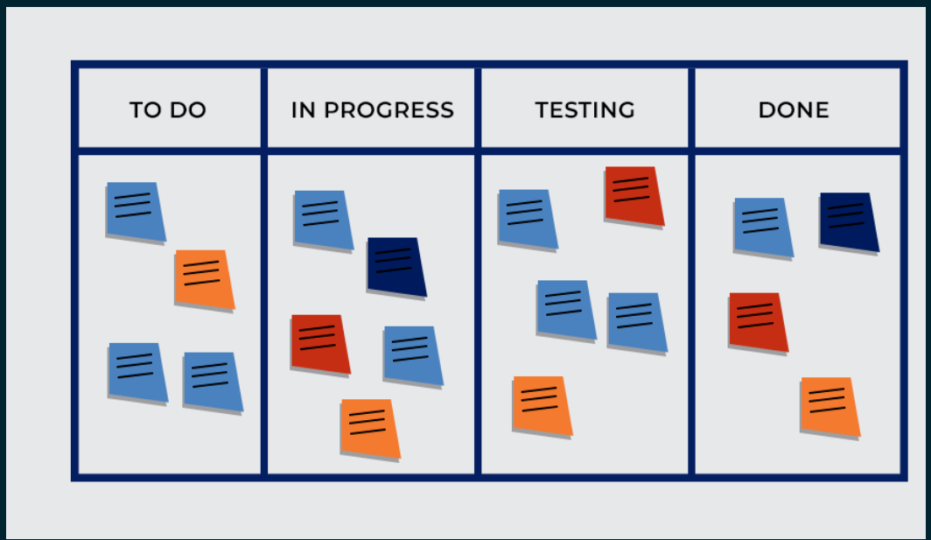

Various workplaces may use different numbers or names for the columns, but the idea of shifting the Kanban card from column to column as work is completed.

## Six General Practices of Kanban

#### Visualize Workflow

#### Limit work in Progress

#### Manage flow

#### Make policies explicit

#### Implement feedback loops

#### Improve collaboratively, evolve experimentally

#### **Visualize Workflow:**

Visualize your activity on a board with cards to represent user stories in your product inventory. Use different colors to illustrate the theme of your user stories.

For a basic Kanban board, tag one column “TO-DO” (to accomplish) and another “DONE” (finished). Label columns in-between “TO-DO” (to accomplish) and “DONE” (finished) to represent either the type of work or whoever undertakes it. Divide these columns into two and label “Doing” (Working) and “Done” (finished). Place the cards into columns according to their workflow status. This allows the whole team to view work in progress, work that has been accomplished, and work to be started next. As work gets done, shift your cards from left to right.

1. Limit work in Progress

The fundamental concept in using Kanban and visual boards is to have every piece of work move from one operation to the next in the most productive way. To bypass barriers and accumulation of work, managers have to set a work-in-progress limit. This limit should equal what can be reasonably performed.

Setting limits will assure that you find the top priority jobs that should be accomplished first and quickly alert everyone when the amount of jobs in one ‘column’ (or operation) exceeds the work in progress limit.

1. Manage flow

The Kanban board enables you to observe how work moves from one column to the next. Focusing on the flow of tasks through the columns on the board highlights any potential bottlenecks and allows managers to focus on smoothing interruptions in the normal flow and seeing where more resources may be needed, for example.

1. Make Policies Explicit

Define, publish, and share your processes and policies. That way, everyone on the team understands how work is done and what your goals are. This helps ensure everyone is moving in the same direction when it comes to suggesting improvements.

Doing this should also help to keep team discussions more dispassionate and objective, preventing emotion and subjective views from influencing the decision process.

1. Implement Feedback Loops:

The most important entity for any business is the consumer and implementing an effective feedback system is very important.

On the Kanban boards, a column can be made for feedback from either an external evaluator or the consumers themselves. In this way, the quality of the delivered work can be maintained constantly.

With the help of Kanban, you have feedback loops of different kinds, including:

* Daily stand-up sessions
* Service delivery reviews
* Operations reviews
* **Risk Review:**

1. Improve Collaboratively, Evolve Experimentally:

The way to achieve continuous improvement and sustainable change within an organization is through collaboratively implementing changes based on Scientifically proven methods, feedback & metrics.

Cultivating and organizational culture where every hypothesis is proven to have positive or negative results is crucial for developing mindset focus on improvement through evolutionary change

## ****Pros of Kanban:****

### **Ease of use:**

Kanban is a very simple and easy to understand approach, which makes it practical for the management of a company to apply effectively. You do not have to be an expert to work with the Kanban approach.

### **Adaptability:**

Kanban encourages maximal adaptability, which is incredible for more extensive ventures that require ongoing changes.

### **Collaboration:**

Kanban advances collaboration and makes the whole team work together to convey the ideal outcomes.

### **Low Overheads:**

Supervision of the use of a Kanban board, cards, and analysis of output is easier as compared to most methods/approaches to project management.

## ****Cons of Kanban:****

### **Cannot be used independently:**

Kanban is not a methodology that can be connected autonomously, or maybe it can be combined with other forms and frameworks of a company like JIT, make-to-order, and scrum, etc., making these frameworks more obvious.

### **Does not fit into a dynamic environment:**

Kanban approach assumes the plans that are stable and consistent to a certain level, it may become feeble in industries where the activities are not still.

3. Lack Of timing:

Another negative point to taking into account before getting started is that a [Kanban board](https://www.kanbanchi.com/google-workspace-kanban-board-options) doesn’t tell you the timescales involved in getting the tasks done. They simply move across the board from one column to the next, with no dates noted on when they need to be completed by.

## Kanban Key Metrics

## Kanban metrics & analytics that you should be using to monitor your team performance and your process efficiency and delivery times, as well as the red flags to watch for that signal trouble ahead.

## Monitoring progress and measuring performance is a key component of the [Kanban Method](https://getnave.com/blog/what-is-kanban-methodology/) – both for tracking your projects and making your processes more efficient over time.

## We had 3 metrics in Kanban.

## 1) Cycle Time 2) Throughput 3) Work in Progress (WIP)

## Cycle Times:

[**Cycle time**](https://getnave.com/blog/little-known-fact-about-cycle-time/) is a key metric in Kanban and it measures how much time a task spends going through your process. Cycle time differs from lead time in that it is only measured from when your team starts working on the task.

Cycle time is the metric that directly measures how long it takes your team to deliver a task. Low cycle times means your team is working efficiently, high cycle times indicate that something is stalling your process. Keeping your cycle times down keeps your lead times down and leads to high customer satisfaction.

## 

## You can see how your cycle times evolve over time using a [cycle time histogram](https://getnave.com/cycle-time-histogram) and use them to predict future work delivery times. In the plot above we can see from the percentile lines that once your team starts working on a task, it has a 50% chance of being completed in less than 6 days and a 95% chance of being completed within 13 days.

## Throughput:

Whereas cycle time measures how long it takes an individual task to go through your process, the [**throughput**](https://getnave.com/blog/kanban-throughput/) metric in Kanban measures the total amount of work delivered in a certain time period. Throughput only measures completed work items – nothing that is still in progress gets counted.

The reason throughput is a key Kanban metric is that it can be used to measure your capacity to deliver results. Consider a Kanban team whose throughput for each of the past 5 weeks was 3, 7, 4, 5, and 6, giving an average throughput of 5 tasks per week. Without knowing anything about the tasks themselves, we can say that this team can deliver on average 5 tasks every week.

Throughput over time is used to track your team performance and is measured using the [**throughput histogram**](https://getnave.com/throughput-histogram). This maps how frequently your team achieves a certain throughput over a period of time. From the chart below, we can see this team has a median output of 3 items per week over the past 6 months.

**[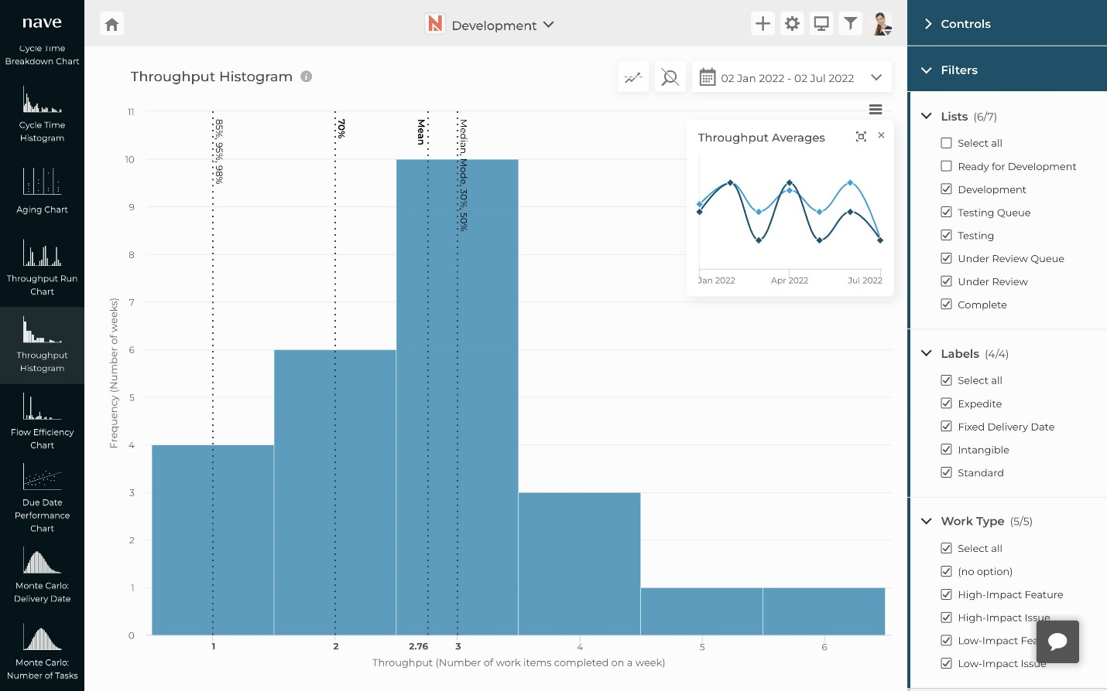](https://getnave.com/blog/wp-content/uploads/2022/07/throughput-histogram.jpg)**

By tracking your throughput over time, you can directly see how your team’s overall performance is changing. Ideally, throughput should stay the same or increase – a decreasing throughput indicates that something is negatively affecting your team’s ability to deliver and needs additional attention.

## Work In Progress

A key component of the Kanban Method is [**limiting Work in Progress (WIP)**](https://getnave.com/blog/introducing-wip-limits/) to improve your team’s efficiency. Think about it – do you get work faster when you split your attention between many tasks, or when you choose one to focus on?

The optimum WIP limit for your team will depend on several factors such as the size of your team, however a good place to start is setting the limit at around the number of people in your team – this way, everyone can focus on one task at a time.

## Team Performance:

The two Kanban metrics that best measure your team performance are cycle times (how fast work gets done) and throughput (how much work is delivered). These metrics are the ones to watch to make sure you are delivering results to your customers!

Cycle time, throughput, and WIP are connected by [**Little’s Law**](https://getnave.com/blog/littles-law/). This formula applies to any system which meets Little’s Law assumptions.

Little’s Law shows the relationship between the three basic flow metrics, and that changing one will have an effect on the other two. For example, for a reduction in cycle time, WIP must decrease.

**Little’s Law:**

Little's Law states the average number of items in a queuing system L is equal to the average number of items arriving at the system per unit of time λ, multiplied by the average waiting time an item spends in a queuing systemW. Expressed algebraically, little’s law appears quite simple: L = λ W.

L – the average number of items in a queuing system

λ – the average number of items arriving at the system per unit of time

W – the average waiting time an item spends in a queuing system

**Little's Law Assumptions:**

Average arrival rate should be equal to the average departure rate throughput.

WIP should be almost the same at the beginning and at the end of the chosen interval.

All work that will enters the process will also exit the process.

Average age of WIP should remain the same.

Short cycle times and high levels of throughput are signs of good team performance, but another thing to look out for is **consistency**. From the cycle time histogram and throughput histogram, you can not only see the average value of your Kanban metrics but also how this data is distributed over a period of time. When your values are spread over a smaller range, your future predictions are naturally more accurate.

## Cumulative Flow Diagram

**Cumulative Flow Diagram** is an analytical tool, fundamental to [Kanban method](https://kanbantool.com/kanban-guide/kanban-method). It allows teams to visualize their effort and project progress. When there's an impediment about to occur within the process - the CFD is where you'll see it first. Instead of the graph staying smooth and rising gently, there will be a bump, a sudden ascend or descend. So, where being able to predict problems is concerned, this is the very graph you need.

**[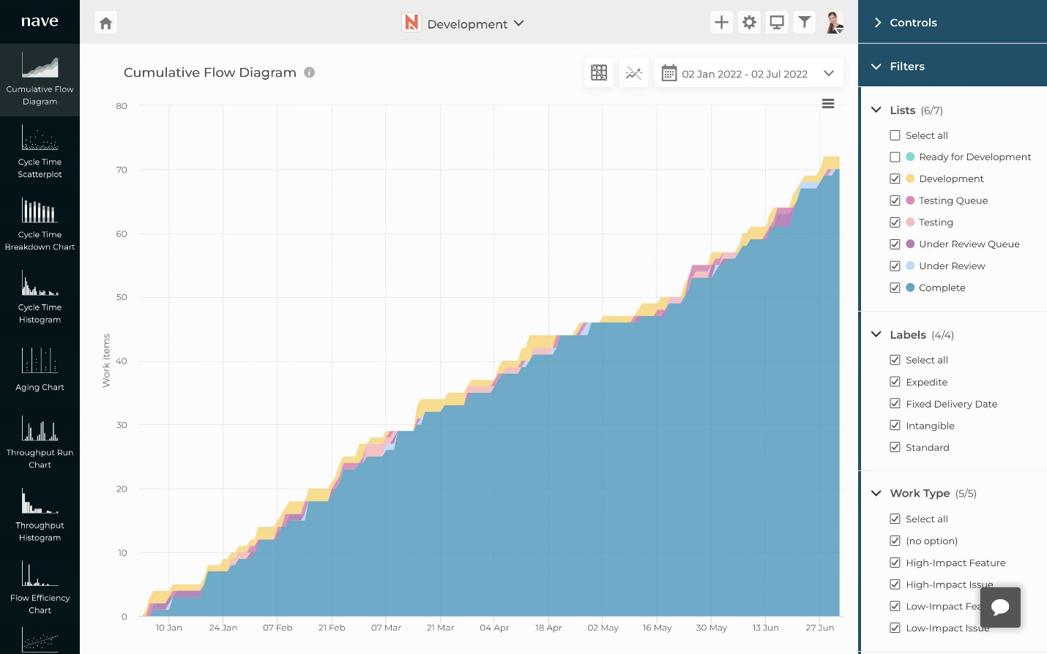](https://getnave.com/blog/wp-content/uploads/2022/07/cumulative-flow-diagram.jpg)**

The cumulative flow diagram shows the distribution of tasks in each of the process states, accumulating over time. Each colored band indicates how many tasks are present in each state of the process at a given time. Approximate average cycle time can be calculated straight from the diagram, but the real benefit of the CFD is how quickly you can get a visual assessment of the stability of your process.

## Kanban with JIRA

## 🡪 After Sign into the Jira there is Create Project button on top of right side click it.

## 

## 🡪 Enter Project name, Key & Select template as Kanban Software development.

## 

## 

## 🡪 If want to add work items/ user stories one by one, we can create by using Create issue on top of the Column.

## 

## 🡪 If want to import bulk Create 🡪 Import issues 🡪 Select project & Issue type 🡪 Create

## 🡪 It allows CSV file format remember.

## 

## 

## 🡪 Select project to import work items.

## 🡪 Map the field CSV to JIRA.

## 

## 

## 🡪Before to assign work items to team need to invite your team into JIRA. Create team & invite them.

## 

## 🡪 People 🡪 Invite team member 🡪 Invite & Add to team repeat the step.

## 

## 🡪People 🡪 Add team members 🡪 Confirm.

## 

## 🡪Click the three dots right side to assign work items

## 🡪 Assign Issues & Team member

## 

## 

## Scrum vs Kanban

## 

## Thank You